COUNTY COUNCILLOR REPORT
TO
ALL PARISH COUNCILS
IN PETERSFIELD HANGERS

1 SEPTEMBER 2025

- The A272 is closed for bridge repairs

Due to the need for repairs to the disused railway bridge, the A272 will be closed between Bordean and the Meon Hut from today for a maximum period of 6 weeks. I wish to stress that this is not a Hampshire County Council closure. The works have been commissioned by National Highways and are being carried out by Amco-Giffen contractors.

Some people may wonder why the bridge is not simply being removed. I asked this question myself and was advised that to remove the bridge would be a much more significant project with a big impact on the surrounding woodland. It is actually a fairly long bridge – it could almost be described as a short tunnel. It has steep embankments above where the old railway line was. On reflection, for reasons of cost efficiency and nature recovery, I agree with National Highways that the bridge should be repaired. There is also a heritage case for retaining and repointing the brick bridge; these Victorian bridges are a legacy of Britain’s industrial age.

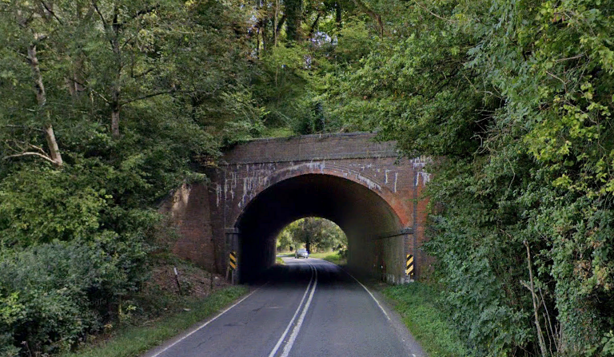

Diversions will be in place from today. If there are any issues with the diversions please let me know so that I can ask Highways to take action. I am in touch with the contractor and I am encouraging them to make every effort to finish early.

- Funding boost for Mental health support in schools

As Executive Member for Health & Wellbeing, I was pleased to announce recently that more children in Hampshire will now benefit from mental health and wellbeing support thanks to an investment of over £100,000 by Hampshire County Council.
The funding will expand the successful “My Happy Mind” programme to primary schools across Hampshire, extending the opportunity for all schools to take part. Designed to help children understand their emotions, build confidence, and cope with life’s challenges the programme takes a whole-school approach to mental wellbeing. Pupils, teachers, and school staff work together through a range of structured activities including classroom discussions, interactive games, school assemblies and playground-based learning. Families can also take part with access to online resources and live coaching sessions.
This investment reflects our strong commitment to supporting the mental wellbeing of children in our communities. Good mental health is the foundation for a good life. This programme is about giving children the tools to understand themselves, manage their emotions, and create a supportive environment for children’s emotional development.
The initiative reflects a growing national recognition of the importance of supporting children’s emotional wellbeing, helping them to be happy, resilient, and ready to learn. With one in six children aged 5 to 16 now likely to have a diagnosable mental health condition, early support is important. By focusing on schools in areas that have not had access yet, the Council is helping to ensure early support is available to children across the county. If you would like to learn more about the My Happy Mind initiative, please visit their website here: https://myhappymind.org

- New provider announced for Hampshire School Meals

You may remember that I reported at the start of the year that Hampshire County Council was exploring the outsourcing of its school meal service. The financial cost of producing meals in-house had become too burdensome due to rising food and staff costs. These costs were in turn putting pressure on school budgets. There were some concerns expressed at the time so I am pleased to be able to report that there has been a positive outcome.

From January 2026, the County Council will provide school meals through a new supplier – Chartwells – under a managed contract. This means that the County Council will keep overall responsibility and oversight of the service but the day-to-day running (such as preparing and serving meals) will be carried out by Chartwells. As part of the change, schools and nurseries subscribed to the service, as well as families who pay for the meals provided at those settings, will see the County Council’s current price of £3.20 drop to £2.75.
Chartwells is the UK’s leading provider of catering to schools, academies, colleges and universities and serves millions of meals to students across the nation. Its meals are produced in line with a rigorous quality assurance process, using sustainably sourced fish certified by the Marine Stewardship Council, as well as 100 per cent British beef, milk, sausages and eggs certified by the British Red Tractor Assurance scheme. It has clear processes in place to manage allergies so that all children can enjoy school meals in a safe and inclusive way.
The company also shares the local authority’s focus on sustainability and reducing food waste, and empowers children with information about health and nutrition, sustainability, and wellbeing through its ‘Beyond The Chartwells Kitchen Education’ programme as well as its ‘Nudge Nudge’ campaign, designed to encourage the uptake of healthier meal choices.
The change means better value for taxpayers, no extra financial risk for the County
Council and continued support for schools and nurseries from the local authority.
Following the announcement, the County Council will work with its subscribed schools and nurseries to ensure they are ready to transition to Chartwells in January.

- Savings agreed to safeguard services

HCC’s Cabinet approved four strands of savings at our Cabinet meeting on 8 August. This decision followed the Future Services consultation earlier this Summer. The changes will amount to annual savings of £9.86m, contributing to the delivery of a balanced County Council budget for 2025/26. The Cabinet has agreed savings in the following areas:
£4.32 million in Highway Maintenance - reducing Local Authority core funding for annual highway maintenance by maximising the use of increased Government grant funding. For 2025/26, this equates to a net extra £3.4 million for structural highway maintenance repairs. This will therefore not impact highway maintenance activities such as pothole and road defect repairs, the renewal of road markings, sign and drainage cleaning.
£210,000 in Older Adults’ Day Services - seeking an alternative provider to deliver and develop day services at Chesil Lodge in Winchester and Newman Court in Basingstoke, to support a wider range of needs within the local population, with both services remaining open and operating as normal pending the recruitment of a new provider.
£2.55 million in Post-16 Transport Only - focusing the County Council’s resources on those most in need, including by amending the eligibility criteria so that the County Council would only assist Post-16 students with special educational needs or a disability (SEND), and who are from low-income families; seeking a contribution from families to the costs of transport for those who are eligible.
£2.77 million in both School Transport and Post-16 Transport - using standing capacity on large buses transporting children to mainstream settings in exceptional circumstances; increasing financial contributions from parents towards discretionary transport; prioritising support for public transport season tickets and personal transport budgets over contracted transport where possible and cost effective.

- Local Government Reform – timetable and next steps

As you know, the County Council consulted on its preferred model of Local Government over the Summer, and that consultation closed on 18 August 2025. Submissions are still being analysed.

I thought it would be helpful to summarise the next steps and the timetable.

24 September – HCC Full Council Decision on final preferred model
26 September – HCC Cabinet Decision on final preferred model
26 September – Final model submitted to Government
Mid-November – HM Government will commence a public consultation on its two preferred models for Hampshire
Jan-April 2026 – Government decision on LGR proposals
May 2026 – Mayoral Election in Hampshire (confirmed)
July-August 2026 – LGR legislation prepared and laid by Government
May 2027 – Elections to shadow Unitary Authorities anticipated
April 2028 – New Unitary Authorities go live. Shortly after this, it is expected that HCC, Districts and Boroughs will be wound up.

I should like to stress that there is currently no certainty about the above timetable. A lot is dependent on legal processes and potential challenges.

RUSSELL OPPENHEIMER
County Councillor for Petersfield Hangers

